Group Highlights
The project is broken down into 3 distinct modules:
1: Obstacle Detection Module
Tanzim Mokammel ( TM ), with the assistance of Valikhan Kuparov (VK) were responsible for this module. The purpose of this module is to utilize the distance data from the sensors, and use it to perform relative speed, and time remaining calculations for determining danger levels, and notifying the user. The module is able to adequately perform these calculations within a certain degree of error (as shown in test results). A major challenge in this module was the treatment of noise on the sensor data. To overcome this, TM and VK implemented various averaging and sample and hold algorithms. The result is much more stable, though somewhat inaccurate and slow calculation of desired values. The module has been tested in cases where the sensor remains stationary, as well as where the sensor is mounted on the user vehicle. The mounting of the sensor required more aggressive averaging, and thus slower acquisition of data.
2. Output Module
VK, with the assistance of TM is responsible for this module. The LCD display is fully functional, and is able to display the distance, relative speed, and time remaining calculations from the microcontroller. The LED light has also been implemented, but it will use varying brightness levels, as opposed to blinking frequencies to represent danger levels. The reason for this is that blinking the LED requires delays to be added to the operation of the microcontroller, and this adversely affects the data acquisition of the sensor. In addition to the LCD screen and the LED, TM has designed an external GUI on a personal computer (PC) to remotely display all the relevant information to the user.
3. Automation Module
Hani Hadidi (HH), with the assistance of TM is responsible for this module. Complete control of the user vehicle has been implemented locally through the slave Arduino. In addition, the user is able to remotely control the car through the designed GUI. The module has also been integrated with the obstacle detection/anticipation module to have an operating steering lock function based on the danger level.

Individual Contribution – Tanzim
My overall responsibility was to develop the obstacle anticipation and detection module. Initially, I researched various models of ultrasonic sensors, as well as types of microcontrollers. Once a sensor and microcontroller were chosen, I implemented the circuitry, and wrote the software required to drive the sensor, and gather distance data from it. With the help of Valikhan Kuparov, I have developed the software required to use the distance data in performing relative speed, as well as time remaining calculations. Developing the speed and time calculation algorithms took multiple iterations due to noise issues from the sensor. In the end, I was able to fine tune the algorithm to achieve satisfactory results as demonstrated by the test results.
In addition to working on the obstacle detection module, I recognized that the initially planned implementation of the output module was not sufficient. Therefore, I worked on developing the external GUI using Processing. The GUI is used to gives the user real-time control of the user vehicle, while displaying real-time plots of the distance, speed, and time calculations. The GUI’s main purpose is meant to demonstrate the project, but it has also been instrumental in debug, and testing.
I have also contributed to certain components of the automation module. The GUI I developed communicates with Hani Hadidi’s control mechanism to provide remote control of the user vehicle using a personal computer (PC). I had assisted in the initial development of the automation module by designing a transistor driven circuitry to control the speed of the motor. Although a better design was later used, the initial design helped us move on the final design using a half-bridge motor driver. I had also assisted Hani debug the motor driver code, and assisted in implementing the steering lock feature by designing the danger look-up table, and integrating the motor driver code with the obstacle detection/anticipation code.
In summary, my main contributions were the obstacle detection/anticipation module, and the external GUI. In addition to this, I have assisted with the automation module, and the overall integration of the final design.

Individual Contribution - Valikhan

Individual Contribution - Hani
My main contributions to the project involved making, implementing and designing the automation module. Few of the main functionalities for the automation include:
- Simulating Driving
- Steering lock mechanism
- Controlling relative speed
- Verify anticipation module
Before deciding on the actual module, one very key component needed to be chosen which potentially affects all other systems, the microcontroller and the remote control cars (RC-cars) for both the obstacle and the user vehicles. The microcontroller that was chosen to accommodate all the modules, including the RC-cars was the Arduino microcontroller.
In addition to the automation module, I also worked in assisting my team members with various tests while performing automation module testing as well as during system integration. The table below is a summary of my contributions with a brief description.
Task | Description
Microcontroller | - Designing the hardware and software to fully control the RC-car after taking out the initial PCB installed
Automation Module | - Designing the circuit and writing the code for the Arduino to communicate with the RC-car motors  - Controlling the speed of the RC-car by modifying the PWM signal
Interface | - Designing and implementing the code for user interface (keyboard)  - Controlling the speed according to various percentages of the PWM-signal
Integration | - Integrating the hardware from the anticipation and detection modules, with the automation module onto one breadboard  - Assisting the team with the testing to verify functionality  - Debugging problems associated with the final integration
Table 1: Summary of tasks

Acknowledgements
With the completion of our design project and soon our term at the University, we would like to take this opportunity to thank the following individuals and resources for their support and contributions:
- Professor Micah Stickel , for constantly providing guidance and mentorship throughout the project
- Professor Ross Gillett, for providing administrative support and feedback throughtout the project
- Mike Mehramiz, Design Center, for granting access to tools and other resources needed
- Lawrence Chan, Creatron, for providing most of the purchased components

In addition to the individuals mentioned above, the completion and success of our project would not have been possible without the testing equipment and the facilities from the Electrical and Computer Engineering Department within the University of Toronto.

Table of Contents
Introduction- 3-7 pages 12
Project Description 12
Background and Motivation 12
Project Goal 12
Project Requirements 12
Functional Requirements 12
Constraints 13
Objectives 13
Final Design 5-10 pages Technical Design 13
System-Level Overview 13
Module-Level Description 14
Work Plan 16
Gantt Chart 16
Testing and verification 3-7 pages 16
Validation and Acceptance Test 16
System-Level Test Results 17
Module-Level Test Results 17
Summary and conclussion 1-2 pages 17
Refrences 18
Appendices 18
Appendix A: Gantt chart history 18
Appendix B: Validation and Acceptance test 18
Appendix C 18
Appendix D 18

Project Description

Background and Motivation
Vehicle accidents cause physical injuries, mental trauma, financial loss, and in the most extreme cases: death. According to Statistics Canada, in 2009, there were 123,192 total recorded collisions in Canada. 2,011 of these were fatal [1]. In 1990, total number of collisions was 178,515; 3,445 of which were fatal [1]. As further indicated by Canadian accident statistics (Appendix D), the numbers have decreased dramatically. This decrease can be largely credited to advancements in vehicle safety technology, among other factors. Though there is a decrease, as the numbers indicate, accidents are still a significant issue.

It has been found that 95% of accidents are caused by bad driving behavior [2]. One common driving behavior is to not check the vehicle’s blind spot while changing lanes, which leads to accidents during lane changes. To account for this issue, car manufacturers such as BMW [3], Volvo [4], and Ford [5] are introducing vehicle blind spot assist technologies in their new vehicle models. However, not every driver is able or wants to attain these vehicle models. Therefore, there is a need for a universal and affordable device that can aid users in becoming aware of obstacles in their blind spot. Advances to the currently available technology also need to be made to further prevent accidents in general.

Project Goal
The goal of the project is to aid in accident prevention through a device that will aid users identify and anticipate obstacles in their vehicle’s blind spot. In addition, the device will be able attain vehicle control to prevent the user from steering into obstacles in the blind spot. In order to achieve this, the group will build a prototype to be tested on scaled down vehicles (i.e. remote controlled cars) under simulated road conditions.

Final Design

System-Level Overview
The final design is composed of the four main modules:
- Obstacle Detection/Anticipation
- Output
- Automation
- Remote Graphical User Interface (GUI)
The diagram below outlines these modules:

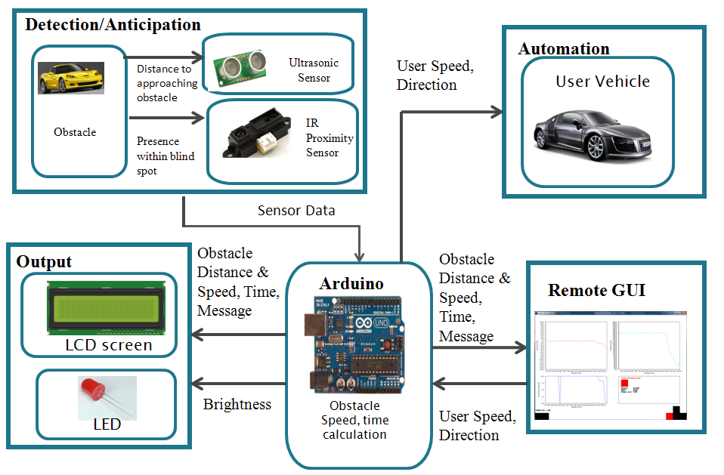
Figure 1: System Level Overview
The core component of the design is a microcontroller, as it is responsible for driving the sensors to gather data from the obstacles, and determine the safeness of the lane change. In addition, it will trigger the automation module in disabling the steering of the vehicle to prevent unsafe lane changes. The output will provide both qualitative and quantitative information to the driver regarding the situation. The remote GUI allows a user to visualize the microcontroller’s calculations through graphs, and also lets them control the prototype user vehicle. Details of each module can be found in the following section:

Implementation
To implement and integrate the 4 modules, we designed 2 major parts. This section will describe these two parts, and the considerations that went into design of each.
- Onboard Implementation
  - Hardware Schematic
  - Description of Components
  - Additional Sensor and Considerations
  - Output Module and Considerations
  - Automation Module and Considerations
  - Onboard Software
- Remote GUI for Control and Output

Onboard Implementation
This subsection describes the hardware and software within the onboard design.

Hardware Schematics
The following is the schematic for the hardware of the design:
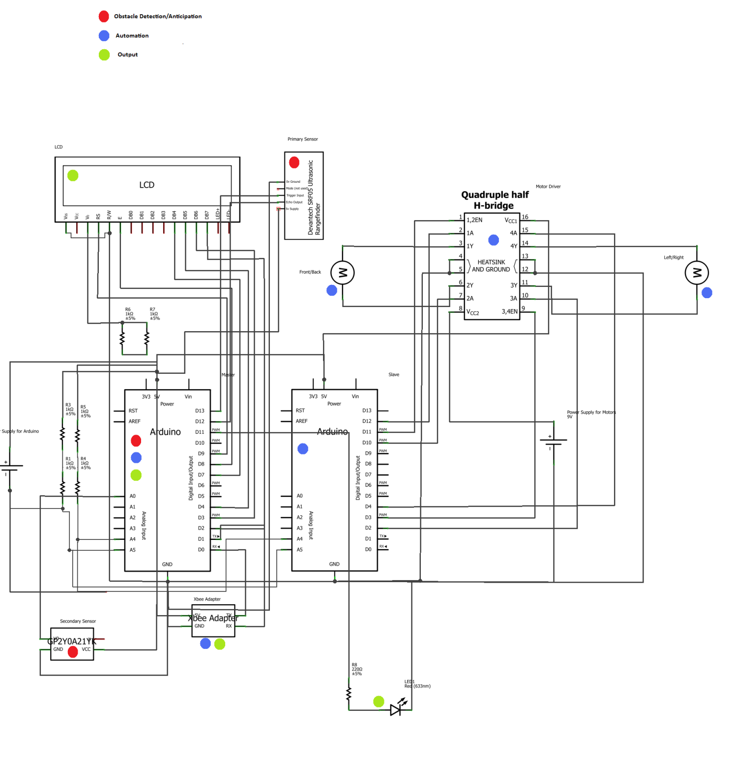
As seen, the main components of the hardware have been labeled according to the module they belong to.

Description of Components
The table below is to further outline the function of each of the major hardware components:
Component | Function | Module
Arduino (Master) | - Drive the sensor  - Perform distance, speed, and time calculations  - Receive commands from the user  - Transmit command to Arduino (slave), receive speed levels from Arduino (slave)  - Drive output (LCD, LED, External) | Obstacle Detection/Anticipation  Output  Automation
Arduino (Slave) | - Operate the motor driver according Arduino’s (Master) commands  - Track speed levels | Automation
Motor Driver (SN754410) | - Regulate the speed and direction of the two motors on the user vehicle (steering, front/back) according to Arduino’s (Slave) commands | Automation
LED Light | - Indicate danger levels with varying brightness | Output
LCD Screen | - Provide summarized information to the user | Output
Ultrasonic (Primary) Sensor (SRF05) | - Gather “time of flight” data to be used for distance values for obstacle anticipation | Obstacle Detection/Anticipation
Infrared Proximity (Secondary) Sensor (GP2Y0A21YK) | - Detect obstacles in the blind spot when it is out of the primary sensor’s range | Obstacle Detection/Anticipation
Xbee Wireless Module (Series 1) | - Gather wireless commands from user, and transmit sensor data wirelessly to be used in the GUI | Automation  Output
Table 2: Arduino components and fuctionality

Additional Sensor and Considerations
One major revision in the final design from the proposed design is the addition of an extra sensor. The secondary sensor only covers the blind spot region of the car. This region is not fully covered by the primary sensor due to its placement. The primary sensor is placed to extend the range of the anticipation feature, and as a result and additional sensor is needed to fully cover the user’s vehicles blind spot.
The situation can be seen in the following picture of the physical implementation of the circuit on the user vehicle:

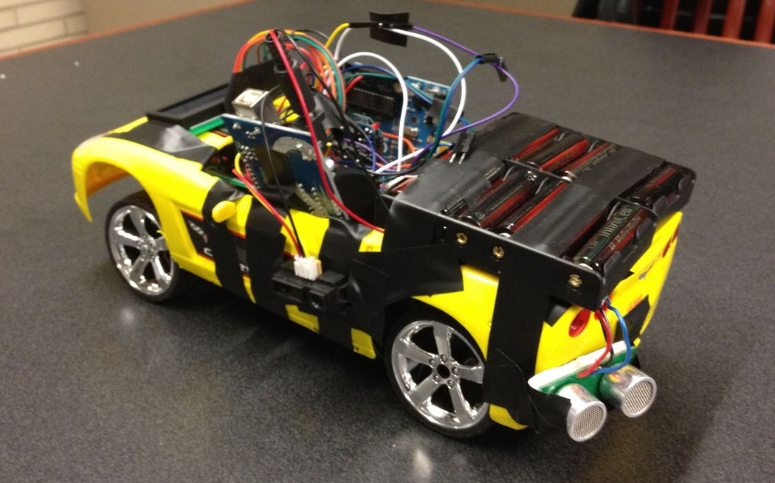
Figure 2: Circuit on the user vehicle

Output Module and Considerations
The LCD screen, and the LED are very important components of the design as it acts as the onboard part of the output module. It provides a summary of all the relevant information analyzed by the microcontroller, according to the various danger levels. The danger levels are determined by the time left calculations, and the presence of an obstacle within the blind spot. The following table outlines the behavior of the LCD screen, and the LED:

Situation | Sensor Involved | Time Left [s] | Danger Level | LCD Screen Output | LED Output | Steering Locked
No Danger | Primary | t > 15 | 0 | Distance to obstacle, “No Danger” | Off | N
Obstacle Approaching | Primary | 11 < t < 15 | 1 | Distance to obstacle, relative speed, “Obstacle Approaching” | Brightness from 0% to 78%, depending on increasing distance | N
Obstacle Approaching | Primary | 6 < t < 11 | 2 | Distance to obstacle, relative speed, “Obstacle Approaching” | Brightness from 0% to 78%, depending on increasing distance | N
Obstacle Approaching | Primary | 3 < t < 6 | 3 | Distance to obstacle, relative speed, “Obstacle Approaching” | Brightness from 0% to 78%, depending on increasing distance | N
Obstacle Very Near | Primary | t < 3 | 4 | Distance to obstacle, relative speed, “Caution” | Fully On | N
Obstacle at Blind Spot | Secondary | t ≤ 0 | 5 | “Danger, Check Blind Spot” | Fully On | Y
Table 3: Danger Levels
The LED behavior has been revised from the proposal since blinking the LED requires delay to be added to the software. This delay reduces the frequency of operation of the sensor, and degrades the overall performance of the system. As a result, the current implementation of the output module was designed to ensure intuitive feedback to the user, without sacrificing performance.

Automation Module and Considerations
The automation module is activated if a certain level of danger has been detected. As seen on Table 3, danger levels 4, and 5 activate the steering lock. The reason for this implementation is to maximize user control of the vehicle, but prevent collisions. There are dangers associated with this solution. Due to this feature, more serious frontal collisions may occur. These situations will have to addressed in future iterations of the design.

Onboard Software
To drive all the hardware components in harmony in order for them to perform their required functions, software has been programmed into the two microcontrollers. Some main features of the software can be found in the “Function” column of the two Arduino components in Table 2. The software, with comments explaining the functions of the separate pieces of the code has been included in Appendix X.

Remote GUI for Control and Output
It was noted that the LCD screen wasn’t a sound enough output needed for the debug, testing, and demonstration of the project. Therefore, a remote GUI was designed. The main functions of the GUI are:
- Remote control the user car for testing and demonstration
- Remotely output the microcontroller’s (Arduino Master) output in a graphical form for debug, testing, and project demonstration
The following is a screenshot of the GUI:
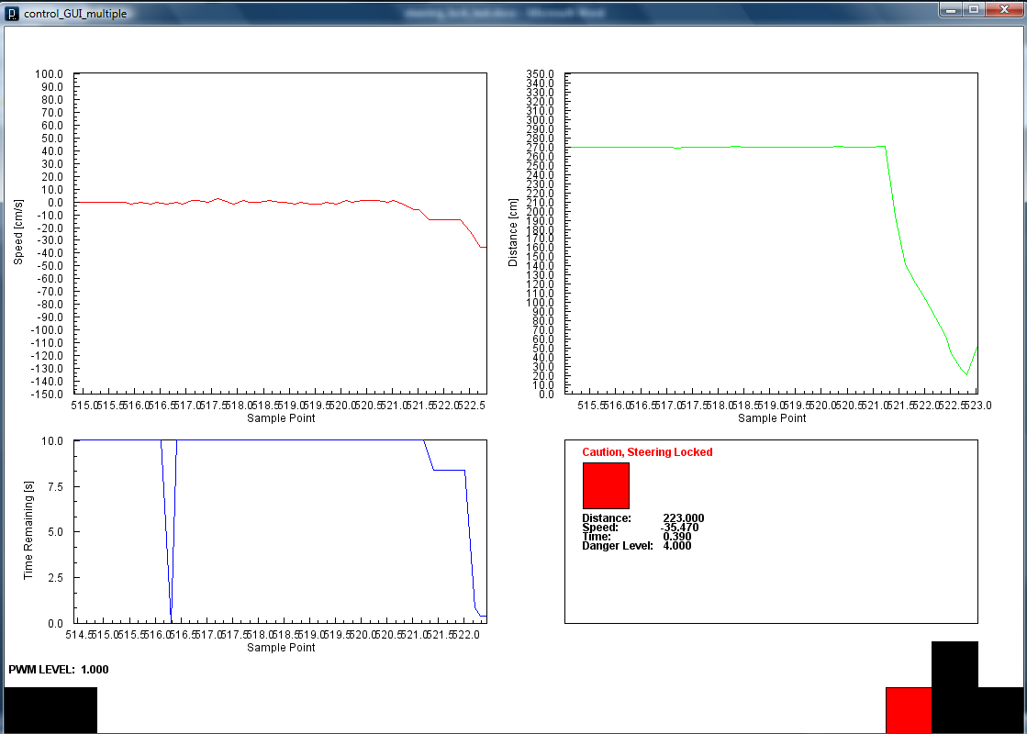
The GUI consists of the following components:
- Real-time plots
  - Relative Speed
  - Distance
  - Time Remaining
- Summary Box mirroring a combination of the physical LED, and LCD screen; outlining information regarding danger levels, and instantaneous readings from Arduino Master
- Indication of the current speed level (motor PWM) of the users vehicle
- Virtual buttons indicating the following controls:
  - Accelerate
  - Reverse
  - Steer Left
  - Steer Right
  - Increase Speed Level
  - Decrease Speed Level
The GUI has been written in Processing, and the commented code can be found in Appendix X.

Assessment of Final Design
The final design meets most of the requirements set at the time of the proposal. However, there are various problems that need improving:
- Due to the implemented averaging algorithm, the response time of the system is slow. As a result, user feedback isn’t instant. This may be dangerous if the obstacle vehicle is moving at a much faster speed than the user vehicle
- Despite efforts to stabilize the sensor data, there is often noise on the data. This results in unreliable speed and time remaining calculations, and thus results in misleading feedback to the user.
- The steering lock feature is dangerous in real life situations
- The GUI, and the LCD screen is not user friendly
- Brightness, instead of frequency was used to indicate danger levels on the LED due to design restrictions. Brightness is often hard to differentiate, especially considering various lighting conditions.

These are the aspects of the design were successful:
- In cases where the obstacle vehicle remains fully within the sensor’s range, the system is able to accurately calculate the relative speed, distance, and time remaining as initially required.
- Due to the addition of an external sensor, the blind spot is fully covered
- The system is able to anticipate obstacles in the blind spot due to a sensor having a large range
- The LCD screen effectively displays the essential information needed for the user to make an informed decision regarding lane changes
- The GUI plots the calculations in real time, and help user’s visualize the situation

Validation and Acceptance Test
The test plan for individual modules of the design is outlined in the following table:
Module | Requirements | Test | Acceptance Criteria
Obstacle detection/anticipation | Sensors should measure distances accurately | Place obstacles at 4 different distances(3cm, 1m, 2m, 3m) away from the sensors | Computed distances match the measured distances within ±2.5% error
Obstacle detection/anticipation | Blind spot Coverage | Mount the sensors on the remote controlled (RC) car to cover the defined blind spot (Appendix F); place obstacles within it | The sensors detect the presence of the obstacle within the defined range
Obstacle detection/anticipation | Microcontroller should compute relative speed based on distance values | Mount sensors to the RC car; place an obstacle and the RC car in motion with a known relative speed | The microcontroller’s calculated speed values match the known value within ±5% error
Obstacle detection/anticipation | Obstacle Anticipation | Set up situations where both distance and relative speeds are known, and perform allowed time calculations with the microcontroller | The microcontroller’s time values match the calculated ones within ±12% error
Output | The Light Emitting Diodes (LED) and the display should provide accurate feedback to the user | Observe the feedback response of the LED and the Liquid Crystal Display (LCD) display | The LED should behave according to the defined look-up table (Appendix H); the display should contain calculated values of distance to obstacle; relative speed, and time left for a lane change
Automation | The steering of the RC car should lock when necessary | Simulate the extremely dangerous, and very unsafe cases (Appendix H) | The steering of the user car is irresponsive in the direction of the obstacle

Module-Level Test Results
Module: Obstacle Detection/anticipation
Requirement: | Correct performance of Sensor
Target Specification: | Computed distances should match measured distances within ±2.5%
Final Result: | Results show at most 1% error in distance computations
Compliance: | Pass
Comments and Documentation: | Objects were placed at 4 different distances from sensor (5cm, 1 m, 2 m, 3). Values obtained from sensor have very high accuracy and therefore verify the correct performance of the sensor SRF05. Detailed results are shown in Appendix 1.

Requirement: | Sensor’s full coverage of Blind spot
Target Specification: | Sensor should cover entire blind spot as defined in Appendix BS.
Final Result: | Defined blind spot region is entirely covered
Compliance: | Pass
Comments and Documentation: | At a time an object was placed at different locations within blind spot. In all cases side sensor and back sensor were able to detect presence of obstacle providing distances to this object. Definition of blind spot of prototype (RC car) and obstacle placed in this blind spot are shown in Appendix 2.

Requirement: | Correct computation of relative speed
Target Specification: | Based on distance values microcontroller should calculate relative speed with ±5% error
Final Result: | At most cases microcontroller computations show ±5% error, however due to non-idealities of track and noise disturbances error might go up to ±8%
Compliance: | Pass
Comments and Documentation: | Two cases were tested: 1) stationary user car and approaching obstacle and 2) both cars in motion with relative speed. In first case test was conducted several times and results show a speed of approaching obstacle equal to 104 cm/s. Actual speed measurements state a speed of 106 cm/s and therefore verify correct speed computation. In second case while both cars were moving results show relative speed of (25±2) cm/s. Individual speed measurement of both cars concludes speed 106 cm/s (approaching obstacle) and 82 cm/s (user car), resulting in relative speed of 24 cm/s. Detailed speed measurements and calculations with GUI plots are provided in Appendix 3.

Requirement: | Correct computation of time remaining to safely change lanes
Target Specification: | The microcontroller’s time values match the calculated ones within ±12% error
Final Result:
Compliance: | Pass
Comments and Documentation:

Module: Obstacle Detection/anticipation
Requirement: | Providing accurate feedback to user
Target Specification: | LED should behave according to defined look-up table (Appendix Y)  LCD display should provide values of relative speed, distance to obstacle, and message containing current state of obstacle
Final Result: | LED and display performance completely hits a target specs
Compliance: | Pass
Comments and Documentation: | Different levels of danger were simulated during test. In all cases LED behaved according to look-up table and LCD screen displayed correct values. Results can be found in Appendix 2.

System-Level Test Results
In our project, the Automation module incorporates all other modules. Successful operation of this module entirely depends on performance of other modules. Therefore on the system-level, the testing of Automation module indicates testing of complete design.
Requirement: | Steering of RC car locks in danger levels 4-5 (see look-up table Appendix Y)
Target Specification: | In presence of obstacle in blind spot or small remained time to change lane, the steering of user car is locked towards the direction of obstacle
Final Result: | Lock steering is enabled while moving when obstacle within blind spot region and when no time left to change lanes safely
Compliance: | Pass
Comments and Documentation:

Summary and conclussion 1-2 pages

Refrences

Appendices

Appendix A: Gantt chart
Gantt Chart (final)

Gannt Chart (Progress Report)

Gannt Chart (proposal)

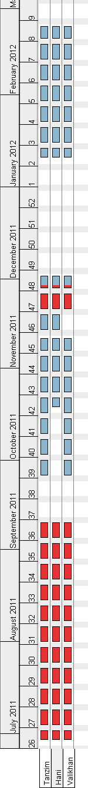
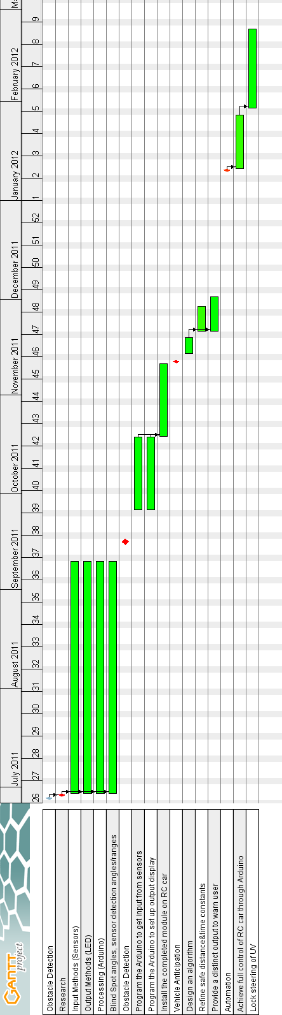

Appendix B: Validation and Acceptance test

Appendix C

Appendix D

